1. Maximum Coins You Can Get

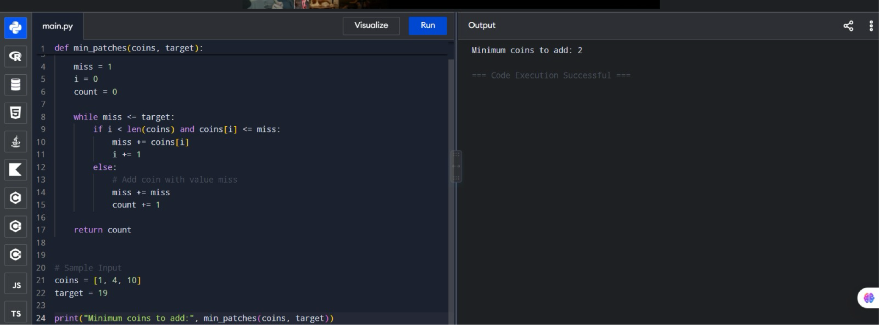

2. Minimum Number of Coins to Add
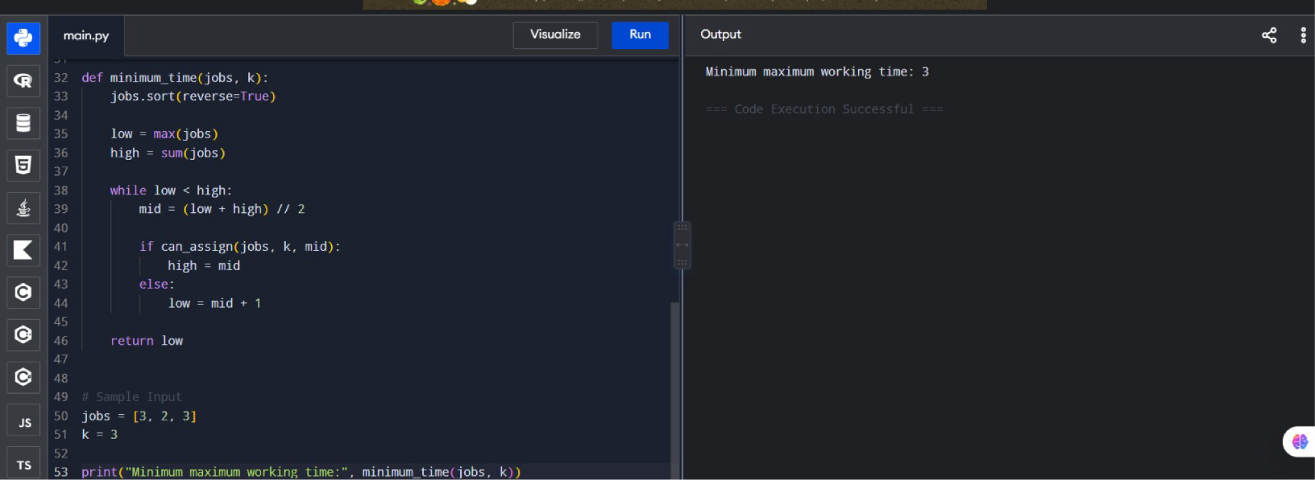

3. Minimum Maximum Working Time

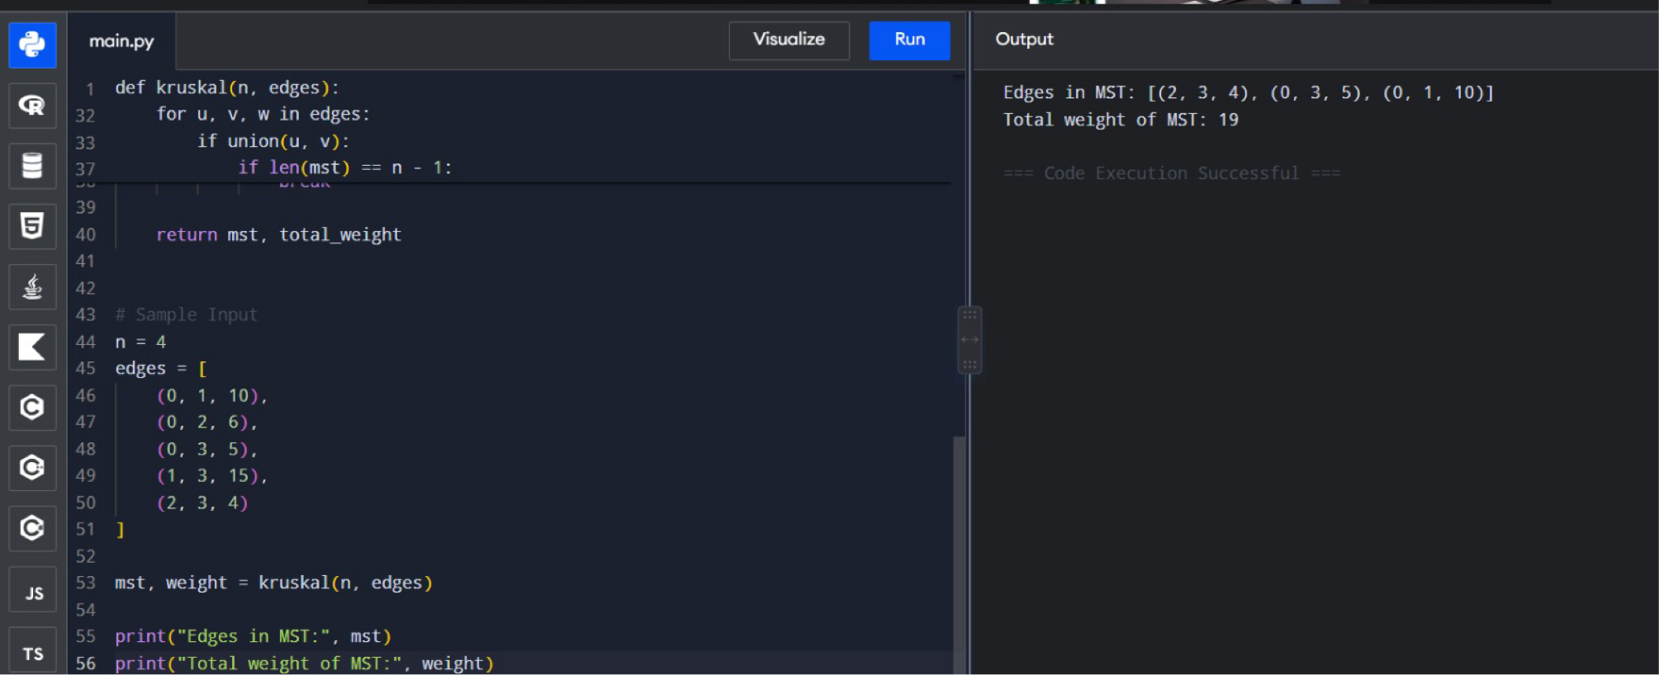

4. Maximum Profit in Job Scheduling

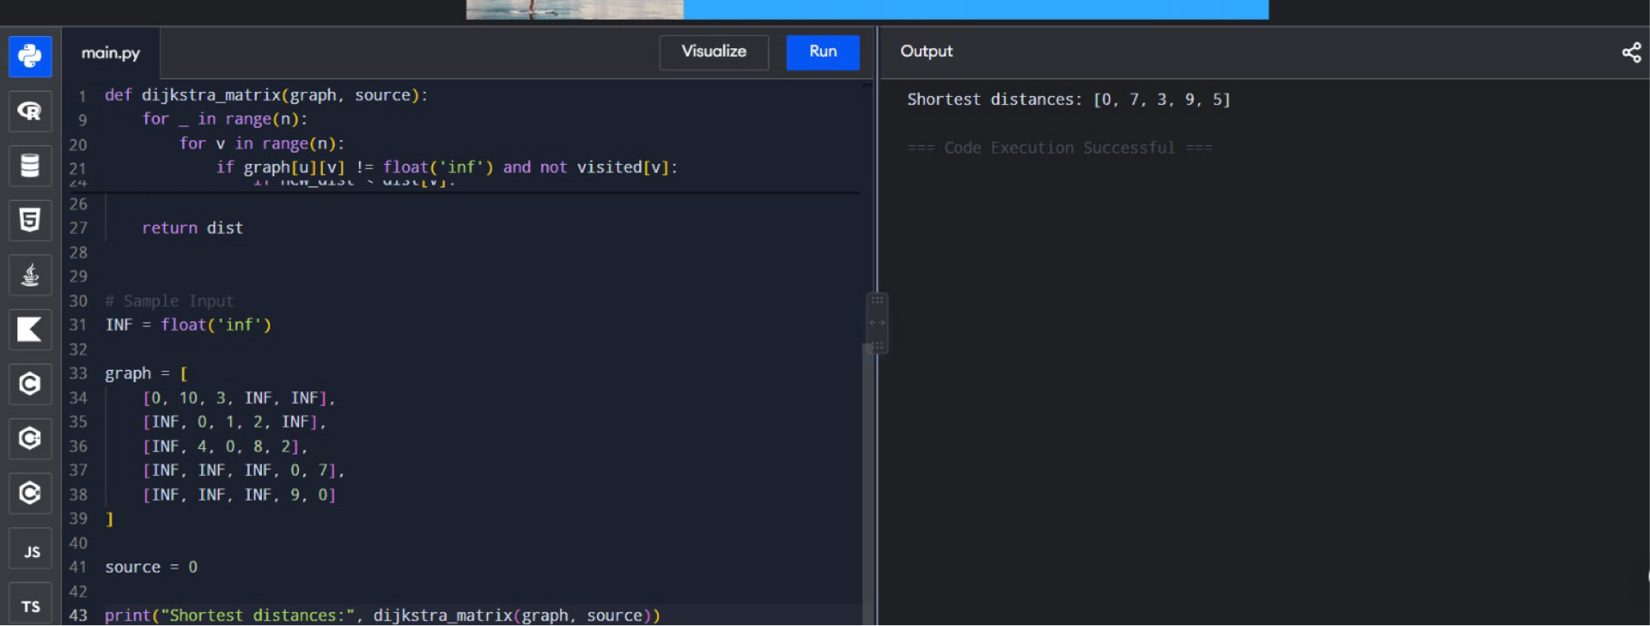

5. Dijkstra's Algorithm – Adjacency Matrix

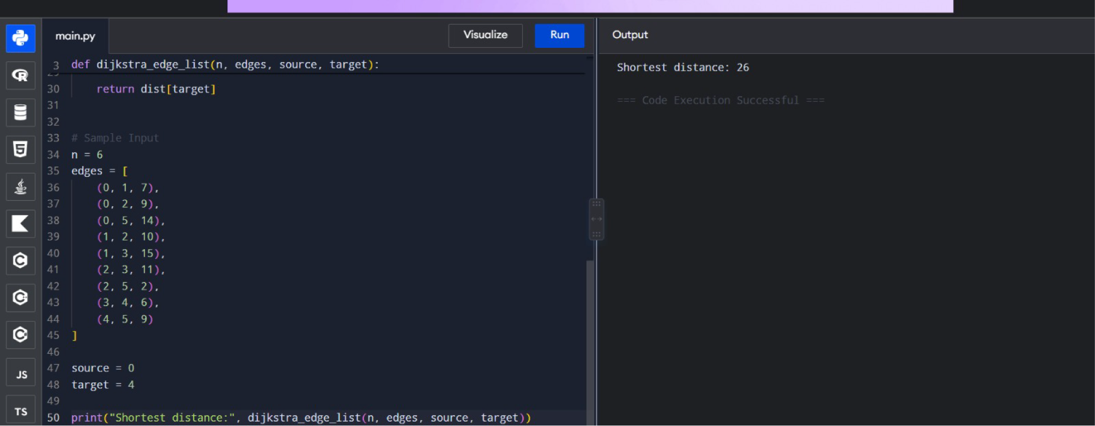

6. Dijkstra's Algorithm – Edge List

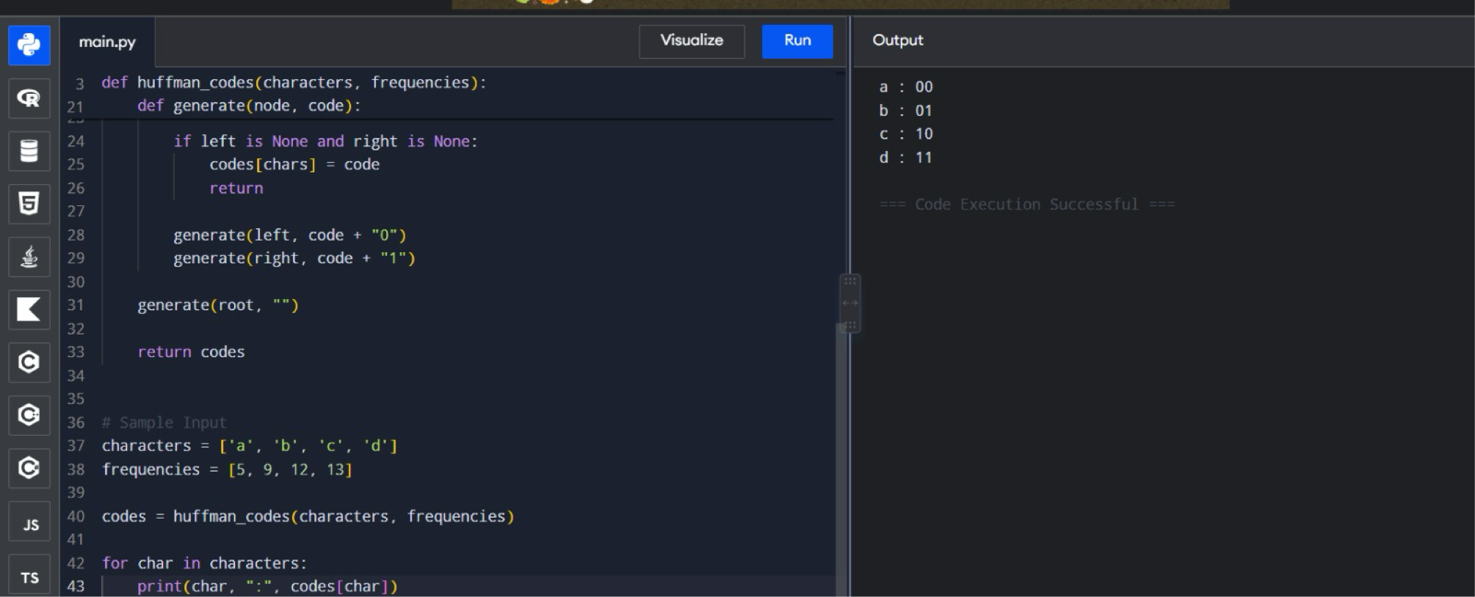

7. Huffman Tree – Generate Codes



8. Huffman Decoding

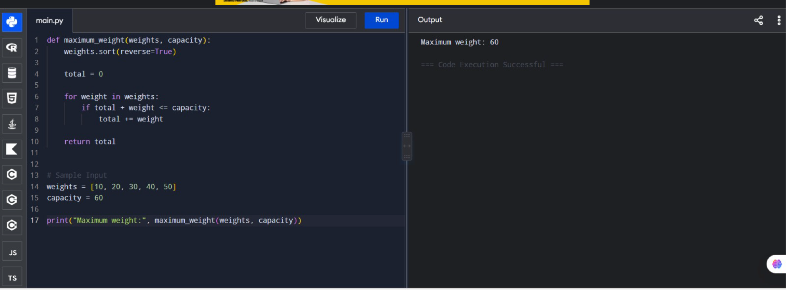

9. Maximum Weight Using Greedy Approach

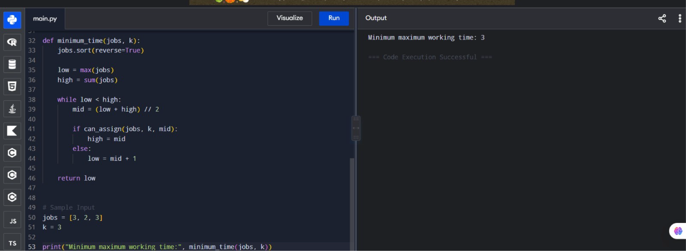

10. Minimum Containers Using Greedy Approach

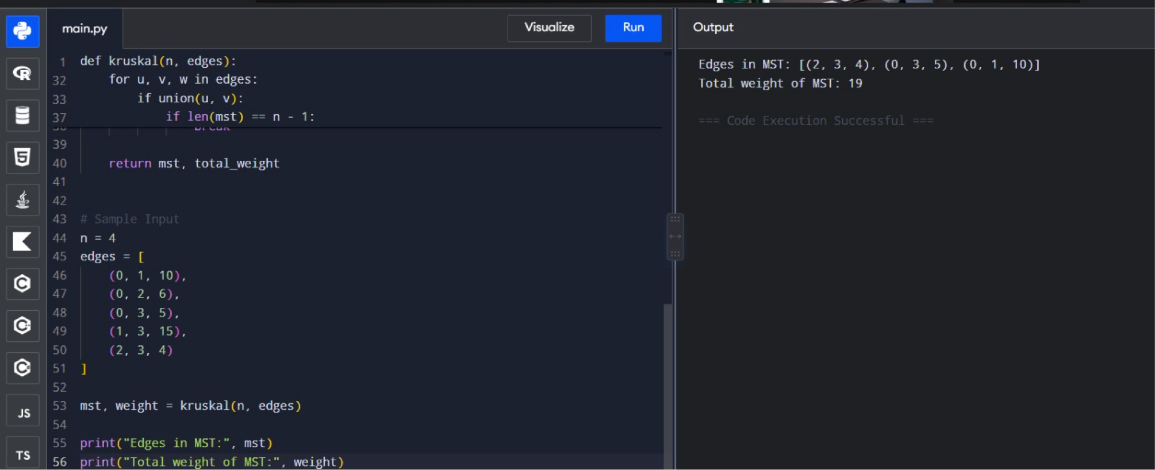

11. Kruskal's Algorithm – Minimum Spanning Tree

